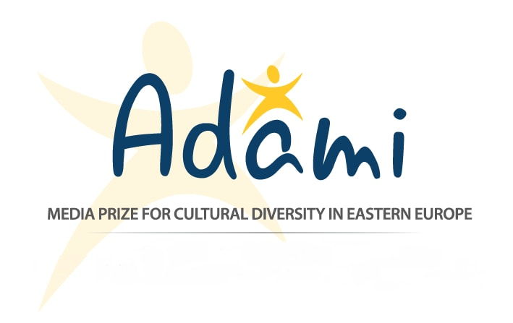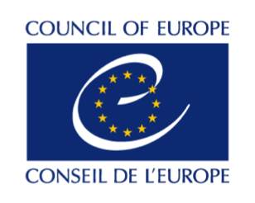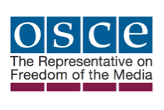

Press Release
September 30, 2016

The Secretary General of the Council of Europe and the OSCE Representative on Freedom of the Media are patrons of the ADAMI Media Prize 2016 award gala

The ADAMI Media Prize is proud to announce that the Secretary General of the Council of Europe, Mr. Thorbjørn Jagland, and the Organization for Security and Cooperation in Europe (OSCE) Representative on Freedom of the Media, Ms. Dunja Mijatović, are the patrons of the 2016 awards gala of the ADAMI Media Prize for Cultural Diversity in Eastern Europe. The prize applies to the six EU Eastern Partnership countries -- Armenia, Azerbaijan, Belarus, Georgia, Republic of Moldova, and Ukraine -- and awards outstanding television, film, and online programmes that promote themes of integration, migration, and ethnic, religious, and cultural diversity. The awards gala will be held in Kiev on November 24th.

In cooperation with the Council of Europe, the director of the ADAMI Media Prize will present the ADAMI project to the Parliamentary Assembly of the Council of Europe (PACE), in Strasbourg, France, on October 11th, 2016. Three filmmakers from the South Caucasus who won the top prizes in the 2015 competition will also travel to Strasbourg, and will screen their films before the Parliamentary Assembly of the Council of Europe.

The Council of Europe works to guarantee human rights, democracy, and the rule of law in Europe; the Secretary General of the Council of Europe is responsible for the strategic management of the organization. The OSCE Representative on Freedom of the Media observes media developments in the OSCE participating States, provides early warning on violations of freedom of expression and media freedom, and helps participating States abide by their commitments to freedom of expression and free media. “As a prize that seeks to promote peaceful co-existence between peoples in Eastern Europe through media, we are thrilled to have the patronage of the Secretary General of the Council of Europe and the OSCE Representative on Freedom of the Media, and believe their auspices will boost larger interest in topics of cultural diversity and integration,” said Mr. Stefan Tolz, programme director of the ADAMI Media Prize.

Television broadcasters, producers, journalists, and young filmmakers of the six participating countries can apply for the competition and send in their films, videos, and online content connected to integration and cultural diversity until October 10th, 2016. An international jury will view and evaluate all entries. Producers and directors/journalists that are nominated in one of the six ADAMI categories are invited to the gala award ceremony in Kiev, where they will have the opportunity to network with broadcaster representatives and media professionals from across Europe.

About the Council of Europe
The Council of Europe is the continent's leading human rights organisation. It includes 47 member states, 28 of which are members of the European Union. The Council of Europe promotes human rights through international conventions, such as the European Convention on Human Rights, the Convention on Preventing and Combating Violence against Women and Domestic Violence and the Convention on Cybercrime. It monitors member states' progress in these areas and makes recommendations through independent expert monitoring bodies. For additional information, visit: www.coe.int.

About the OSCE Representative on Freedom of the Media
The OSCE Representative on Freedom of the Media observes media developments in all 57 OSCE participating States. She provides early warning on violations of freedom of expression and media freedom and promotes full compliance with OSCE media freedom commitments. Learn more atwww.osce.org/fom, Twitter: @OSCE_RFoM and at www.facebook.com/osce.rfom.

About the ADAMI Media Prize
The ADAMI Media Prize spotlights the work of journalists and media professionals in the EU’s Eastern Partnership countries. ADAMI’s goal is to promote peaceful coexistence between peoples by stimulating new ideas and perspectives in media, and promoting media interest in topics of cultural diversity and integration. The ADAMI Media Prize is funded by the Federal Foreign Office (Germany) and ProCredit Group. It is conducted in partnership with the European Broadcasting Union, Deutsche Welle Akademie, the German Society for Eastern European Studies, and supported by media partners ARTE, ZDF, the Georgian Public Broadcaster, the National Television of Ukraine, and TeleRadio-Moldova. For additional information, visit: www.adamimediaprize.eu.

